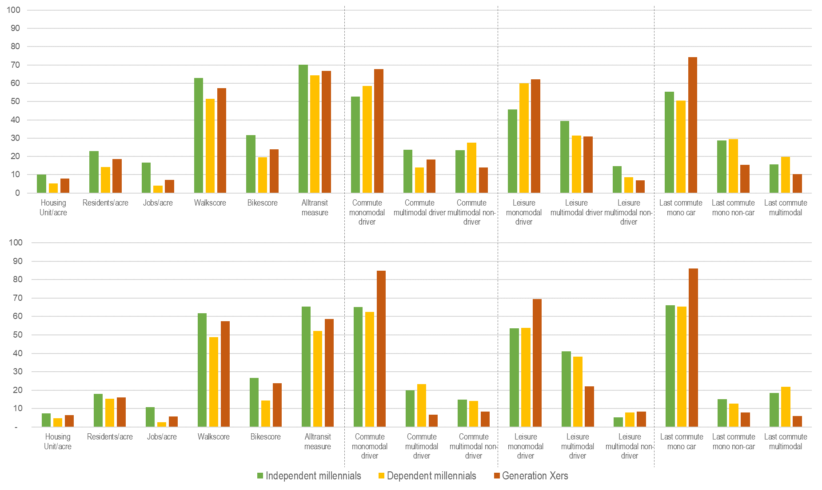

**Figure 5: Accessibility level and adoption of multimodality, by generational group, in (a) the San Francisco Bay Area (MTC); and (b) the Greater Los Angeles region (SCAG)**